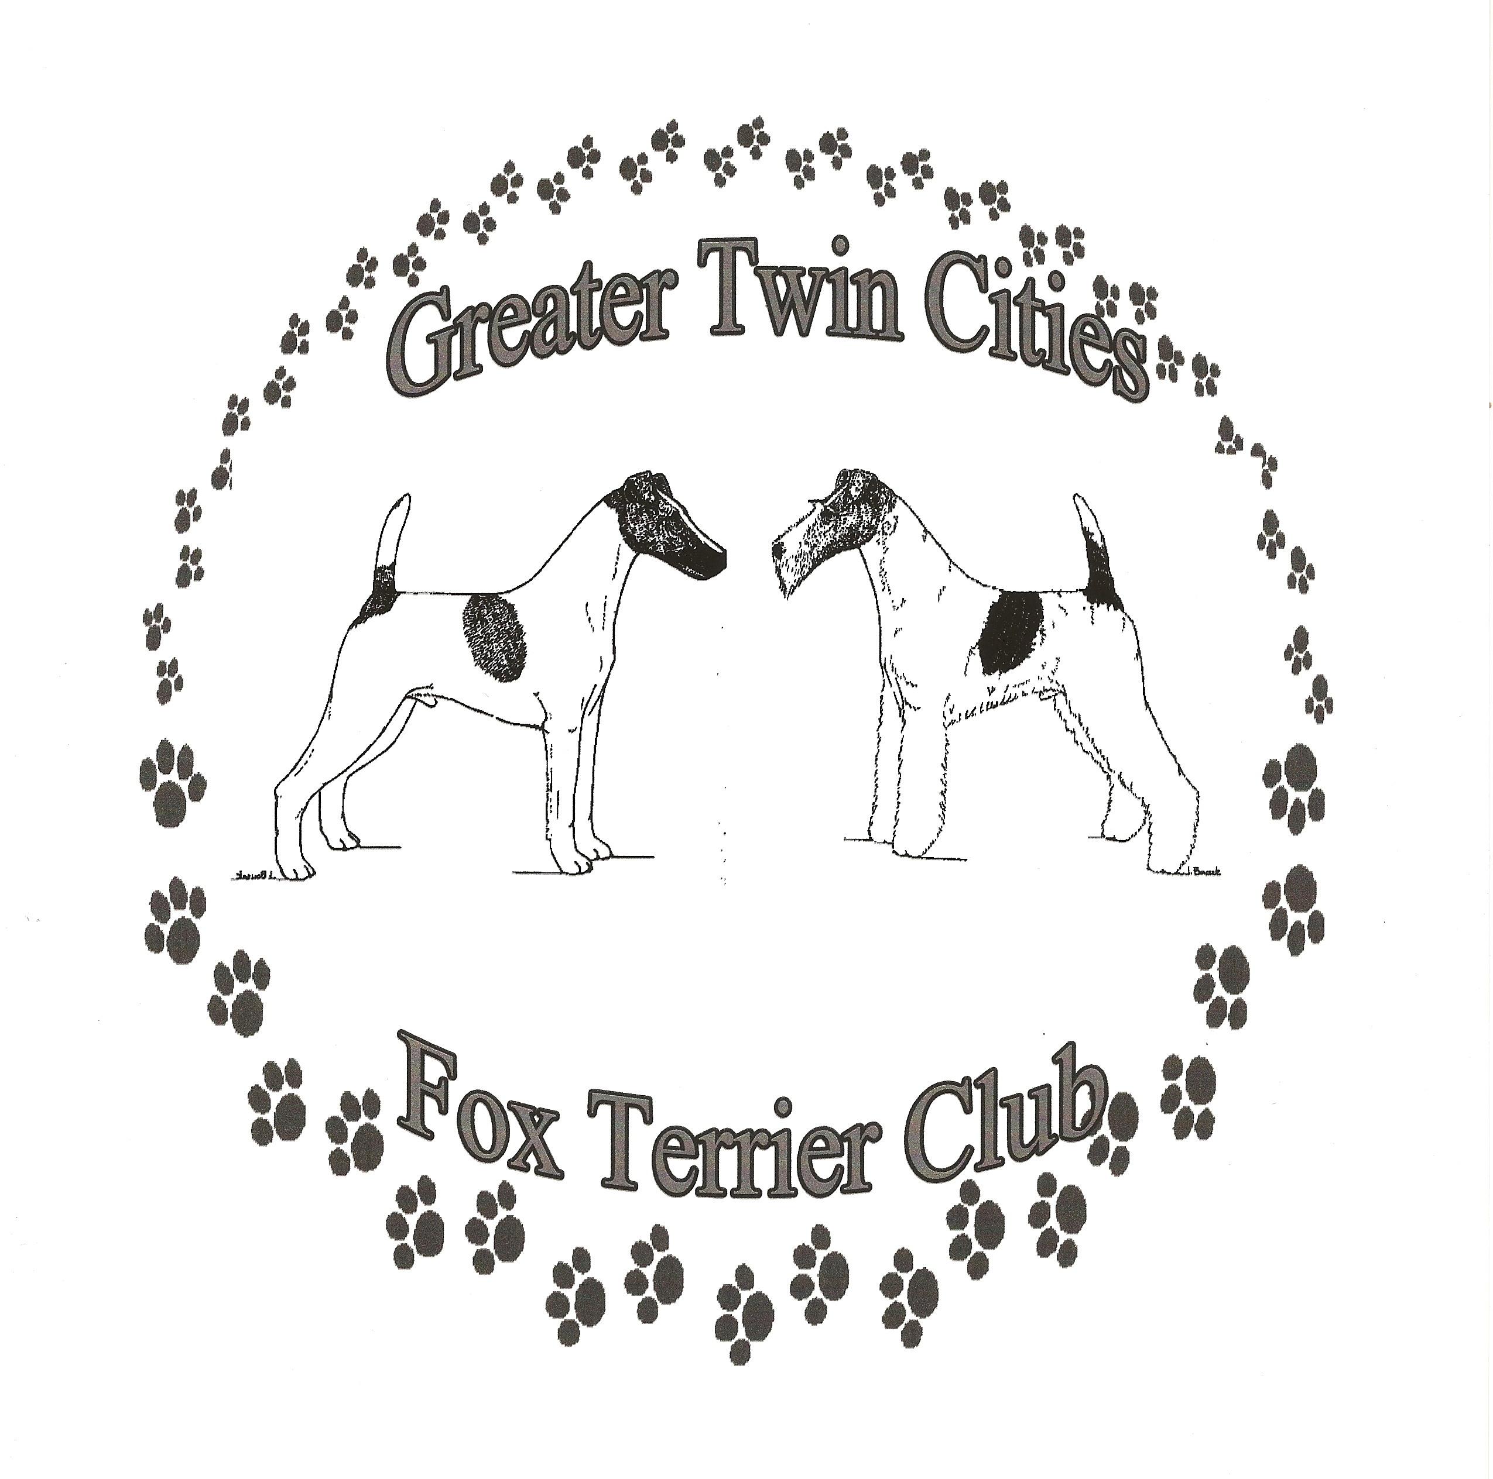
Champaign Illinois Kennel Club
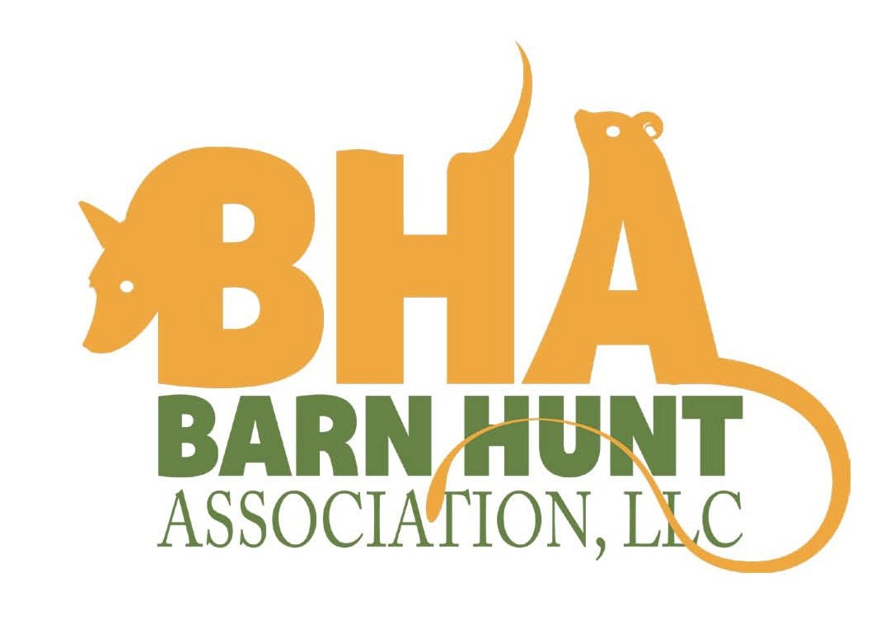
Presents
BHA Sanctioned Fun Test
May 22, 2015 (Friday)
Interstate Center
Building A
2301 West Market
Bloomington, IL 61705

LIMIT: 50 Runs

Permission has been granted by the Barn Hunt Association, LLC for the holding of this Barn Hunt Fun Test under BHA Rules and Regulations.
Open to all Breeds and Mixed Breeds of all sizes.

6:00 p.m. Instinct, Novice, Open - FTLE-15117
Fun Test Judge: Deb Auer – Springfield, IL

DAY OF FUN TEST ENTRIES WILL BE ACCEPTED ONLY IF SPACE IS AVAILABLE. PRE-ENTRY IS STRONGLY SUGGESTED!
ENTRIES OPEN APRIL 1, 2015 CLOSES MAY 18, 2015

FUN TEST COMMITTEE
Trial Committee | Lori Yotter, Elise Singer, Karen Passow,  Donna Johnson
Trial Secretary | Elise Singer  506 E. Illinois  Arthur, IL 61911  Singer5@consolidated.net  217-254-3791
Trial Chair | Donna Johnson  donnaj@myclearpathadvisors.com

DAY OF REGISTRATION: 4:30 P.M. - 5:30 P.M.
JUDGE'S BRIEFING: 5:45 P.M.
JUDGING START TIME: 6:00 P.M.
RUNNING ORDER: Instinct followed by novice followed by open. Small to Tall. Dogs will be run in height order with dogs being handled by the same person separated into different blinds.
HEIGHT DIVISIONS: Small - Dogs <13".
Medium - Dogs 13.1" to 18" Large over 18"

EXHIBITOR INFORMATION

The rules for BHA Fun Tests and Trials can be obtained online at: www.barnhunt.com

This is a Fun Test, therefore NO titling legs will be awarded.

All dogs must be on a short leash and under control while on the test grounds except while showing. Approved collars include flat snap or buckle collars of solid construction and leather or nylon leads. Single piece slip collars/leads are allowed. Harnesses, with the exception of head halter types, are allowed. Dogs must run "naked", without a collar/harness. No flexi-leads are allowed.

CRATING: There is plenty of crating space available. Please make sure your crate is secure as the dogs may become highly excited. Bring adequate water for you and your dogs.

BITCHES IN SEASON: Bitches in season are eligible for entry but will be required to be kept separate from all other dogs. Bitches must wear "panties", and will run at the end of their class level. If bringing a bitch in season, please inform the test secretary prior to the test and inform all exhibitors at the judges briefing.
VETERINARIAN: Animal Emergency Clinic
2505 E. Oakland Ave
Bloomington, IL 61701
(309) 665-5020

DIRECTIONS TO INTERSTATE CENTER: From I-55/74 take exit 160B onto Rt 9 toward Pekin (W. Market Street). Turn right onto Interstate Drive (Circle K station on the corner). Once you enter the Interstate Center grounds, Building A will be the 2nd building on your left.

OTHER BARN HUNT ACTIVITIES OCCURING DURING THE HEART OF ILLINOIS CLUSTER WEEKEND

Prairieland Standard Schnauzer Club
will be offering 1 hr Introduction to Barn Hunting seminars on Friday and Saturday in Building A. Dogs will have a chance to meet the rats, learn what the required elements are in a barn hunt and have a chance to try to find a hidden rat. Handlers will learn about the sport, rules and how to get involved. Registration will take place on site and be limited to 5 per hour. Cost will be $20 For more information contact Penny Duffee at duffpnb@aol.com

Greater Twin Cities Fox Terrier Club
will be offering an official Barn Hunt Fun Test on Thursday, May 22 in Building A. Donna Johnson will be the judge. Premium and entry forms can be found on the GTCFTC site http://gtcftc.homestead.com or contacting Karen Passow at pathwire@gmail.com Day of entries starting at 4:30 - 5:30 p.m. Instinct, Novice and Open classes will be offered.
Limited to 50 runs.

Champaign Illinois Kennel Club
BHA Licensed Barn Hunt Fun Test
Please Circle Appropriate Class for Each Trial Below
You may enter both Instinct and Novice
Friday  May 22, 2015 | Instinct | Novice | Open

Instinct $8.00 - Novice, Open $10 due with entry if mailed before May 18, 2015
Day of Trial Entries Accepted Instinct $10 - Novice, Open $12
Amount Enclosed

Make Checks payable to: CIKC Send entries to:
Elise Singer – 506 E. Illinois – Arthur, IL 61911

*Dogs are not required to have a Barn Hunt Registration Number to compete in this Barn Hunt Fun Test. If you have one, please enter
Handler:
Barn Hunt #: BH- |  |  |  | Birthday:
Call Name: |  | Sex: M F |  |  |  | Height: S M L
Breed: |  |  | Actual Height: in
Registered Name:
Owner(s):
Address:
City: | State: |  |  |  | Zip
Email:
Cell Phone:

CERTIFICATION OF AGREEMENT UPON ENTRY OF DOG
I certify that I am the actual owner of the dog, or that I am the duly authorized agent of the actual owner whose name I have entered above. In consideration of the acceptance of this entry, I (we) agree to abide by the rules and regulations of the Barn Hunt Association, LLC in effect at the time of this event, and by any additional rules and regulations appearing in the premium list for this event, and further agree to be bound by the liability waiver enclosed with my entry. I (we) certify and represent that the dog entered is not a hazard (dog or human aggressive) to persons or other dogs. This entry is submitted for acceptance on the foregoing representation and Agreement. I (we) agree to conduct myself (ourselves) in accordance with all Barn Hunt Association, LLC Rules and Regulations and to abide by any decisions made in accord with them.

Signature of owner or her/his duly authorized to make this entry Date

LIABILITY WAIVER
In consideration of the acceptance of this entry and of the holding of this event and of the opportunity to win prizes, ribbons, and/or trophies. I (we) agree to hold Barn Hunt Association, LLC, Greater Twin Cities Fox Terrier Club, their directors, governors, officers, agents or event secretary, and the owner and/or lessor of the premises and any provider of services that are necessary to hold this event and any employees or volunteers of the aforementioned parties, and any BHA LLC approved judge, judging at this event, harmless from any claim for loss or injury which may be alleged to have been caused directly or indirectly to any person or thing that the act of this dog while in or about the event premises or grounds or near any entrance thereto, and I (we) personally assume all responsibility and liability for any such claim; and I (we) further agree to hold the aforementioned parties harmless from any claim for loss, injury or damage to this dog.
Additionally, I (we) hereby assume the sole responsibility for and agree to indemnify, defend and save the aforementioned parties harmless from any and all loss and expense (including legal fees) by reason of the liability imposed by law upon any of the aforementioned parties for damage because of bodily injuries, including death, at any time resulting there from, sustained by any person or persons, including myself (ourselves), or on account of damage to property, arising out of or in consequence of my (our) participation in this event, however such, injuries, death or property damage may be caused, and whether or not the same may be caused or may be alleged to have been caused by the negligence of the aforementioned parties or any of their employees, agents, or any persons.

_______ By initialing here, I indicate my agreement with the Liability Waiver

