

**CIKC INC. NEWSLETTER**

## Aug 2016

## Champaign Illinois Kennel Club, Inc.

## Officers

**President…………………….…..… Merle Taylor**

**Vice-Pres……………...…… Colleen Woodcock**

**Treasurer…………………………Carolyn Taylor**

**Recording Sec………………...…Sylvia Lofrano**

**Corres. Sec………………….………...Pat Brown**

## Board of Directors

**Robin Haggard Kris Mullen**

**Elise Singer Van Dukeman**

## Breeder Referral…………...……….….Theresa Swift

## Web Page……………..<http://champaignillinoiskc.com>

## Newsletter……….……..…...……..Colleen Woodcock

**Face Book**…...Champaign Illinois Kennel Club - CIKC

**Legislative Liaison**…………..………..Cynthia Nichols

#### Newsletter

Please send all information for the newsletter to Colleen Woodcock at [ashlandkennel55@gmail.com](mailto:ashlandkennel55@gmail.com) by the end of each month.

##### Membership

Prospective new members must attend two meetings (program meeting count as a regular meeting) before a membership application can be turned in. After it is submitted the application will be read by the board two times before voting on membership. Contact Sylvia Lofrano at: [[sylvial@wirelessdatanet.net](mailto:sylvial@wirelessdatanet.net)](mailto:sylvial@prairieinet.net) for more information.

Legislative Liaison

Cynthia Nichols, Legislative liaison CIKC, Secretary, IFDCO [cdnichols@consolidated.net](mailto:cdnichols@consolidated.net)

Club Calendar 2015-2016

October: Working Meeting

November: Program Meeting

December: No Regular meeting (member’s Christmas gathering)

January: No Meeting

February: No Reg. Meeting*,* Westminster Party Feb 15/16

March: Regular Business Meeting (Show) Health Day on March 12th

April: Regular Business Meeting (Show)

April 28, 29, 30, and May 1, 2016 Progress City Cluster Shows with CIKC on the 28th & 30th.

May: Regular Meeting (Show reports)

June: Program Meeting

July: Social Event (member’s picnic at Monticello)

August: Regular Business Meeting

September: Annual Meeting (Election of Officers, ***no guests***)

September 24, 25: Barn Hunt

**CIKC August Meeting**

The Regular CIKC meeting will be held **Tues August 9th at** **Denny's Restaurant**, located in the area West of Menards in front of HH Greggs at 702 W Town Center Blvd, Champaign, IL 61822 (217 359-7044). The seating area is back past the game room and will be available at **6:30pm** for dinner with themeeting starting at approximately **7:00pm.**

**July Member’s Picnic**

The weather was accommodating for CIKC members who enjoyed a relaxing evening with good food and great company at the Monticello Forest Preserve Park July 12th.

ALL-BREED B MATCH

Offered By

**CHAMPAIGN ILLINOIS KENNEL CLUB**

To be held at

DOG TRAINING CLUB OF CHAMPAIGN-URBANA BUILDING

2210 WEST FORD HARRIS ROAD

URBANA, IL 61802

Located approx. 3 miles N. of I 74 on Route 45,

then ¼ mile East on the Ford Harris Road

**WEDNESDAY, AUG 24, 2016**

**JUDGING BEGINS 7:00 pm**

***\*THIS MATCH WILL BE HELD IN A CLIMATE CONTROLLED BUILDING\****

NO PRE-ENTRIES. ENTRIES TAKEN FROM 6:00 PM TO START OF THAT GROUP

#### JUDGES TO BE ANNOUNCED

ENTRY FEE: $10.00

NOVICE JUNIOR SHOWMANSHIP: NO FEE

NOVICE JUNIOR CLASS 9-under12yrs. NOVICE INTERMEDIATE CLASS 12-under15yrs. NOVICE SENIOR CLASS 15-under18yrs.

3-6 PUPPY

6-9 PUPPY

9-12 PUPPY

OPEN

Exhibition Class

(For dogs with majors or Champions of Record)

# MATCH SECRETARY

**Colleen Woodcock**

***FOR MORE INFORMATION, CONTACT:*** [ashlandkennel55@gmail.com](mailto:ashlandkennel55@gmail.com)

**\*It is required that all participants pick up after their dogs. Use only the areas marked for this purpose.**

**Equipment is available on the grounds along with a proper outside disposal area. If clean up is needed inside the building, please dispose of all solid waste outside in the disposal area.**

**\*Remember that humane treatment of your dogs is imperative at all times, but especially while on club grounds.**

**\*Also remember that Handicapped Parking areas are only for those with the correct parking passes properly displayed.**

Conformation Classes

*Held in the DTCCU Climate Controlled Training Building*

The 6-week Summer Conformation class session ended Aug 3rd. Over the next weeks, we are offering open ring practice at **7:00pm**

Aug 10th, 17th, (24th is the B Match) and 31st.

Classes are held at the Dog Training Club of Champaign-Urbana, 2210 West Ford Harris Road, Urbana, IL 61802 located ¼ mile East of the Ford Harris Road and Route 45 (approx. 3 miles N. of I 74):

(we meet in ring 1 on the North end near the kitchen)

**Please Note**- Use your discretion if weather is a question.

We will try to announce closings on the email list, on CIKC Facebook, and CIKC’s website, DTCCU will also post on Facebook and on Twitter (If the Dog Training Club Classes are canceled…we are not holding classes either)

Drop-in fee - $10.00 per class per person

***(Make checks out to CIKC)***

##### There will be an info card to fill out the first night and a list of rules for use

*of this facility will be handed out to each new participant.*

Please bring an **updated copy** of your dog's **vaccination record** including proof of rabies

with you on the **first night** of class **to be kept in our files**.

Dress comfortably with good “running” shoes. You may want to bring water for your dog also.

For enrollment & information Contact**:**

**Colleen Woodcock** [**ashlandkennel55@gmail.com**](mailto:ashlandkennel55@gmail.com)

**Please Remember:**

**\*All participants and their guests are expected to follow the guidelines set forth by both clubs at all times while on the grounds. Please pick up your copy of the rules at the ringside table when filling out your class card.**

**\*It is required that all participants pick up after their dogs. Use only the areas marked for**

**this purpose. Equipment is available on the grounds along with a proper outside disposal area. If clean up is needed inside the building, please dispose of all solid waste outside in the disposal area.**

**\*Remember that humane treatment of your dogs is imperative at all times, but especially while on club grounds.**

**\*Bitches in season are not allowed to participate. Please contact the class coordinator if you are unable to attend due to your female coming in season. Beginning handlers are encouraged to come and watch.**

**\*Also remember that Handicapped Parking areas are only for those with the correct parking passes properly displayed.**

**Barn Hunt**

CIKC and the Prairieland Standard Schnauzer Club of Central Illinois will be holding another Barn Hunt Trial Saturday September 24th & Sunday September 25th, 2016 at the Bloomington show site.  Mark these dates as we will need all the helpers we can get again.  Don’t forget that you can enter your dog as well.

Find pictures from our last trial at: [**www.barbcunninghamphoto.photoreflect.com**](http://www.barbcunninghamphoto.photoreflect.com/)

Lori & Elise

**>< BRAGS ><**

Wire Fox Terrier, Nova, and I attended the Southaven, Mississippi shows July 14-17.  Nova was Best of Breed each day. On Friday it was a 3 pt. Major, and she was a Group 2 in Owner Handler. On Saturday Nova was Best in Sweeps, Best of Breed which finished her, then she was Group 1 in Owner Handler, and Group 2 in Bred By Exhibitor. On Sunday she was Group 4 in the Terrier Group.  Her new title Champion Starwyre Procyon. ~ Lori Yotter

Bedlington Terrier, Stony Lake Wise Girl, won a 4-point major at the Waukesha Kennel Club on July 30. Kris Mullen

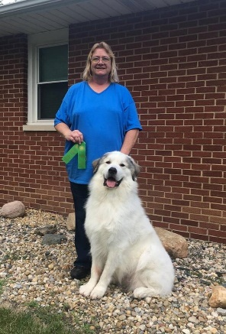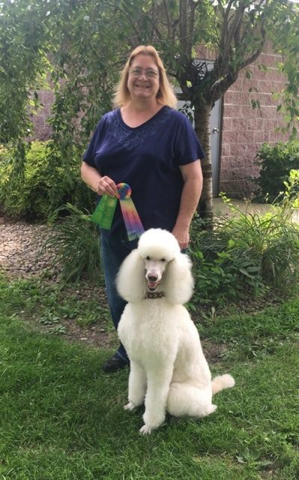Fantastic weekend of 4 AKC Rally Trials in two days at DTCCU. Our Poodle, Justin, put the last two legs on his Rally Excellent title and Tie, our Great Pyrenees, added all three legs to complete his Rally Advanced title.   
I, who am always doubting our abilities to pull off these arduous tasks, am so joyously proud of these two boys!!!!! They have amazed me by earning all their Obedience and Rally titles by completing all 3 legs in a row for every performance title with no NQs (Non-Qualifying Scores) ever in competition, and with most scores in the upper ranges for each event! Much thanks to Mary Mazzela, Darlene Chirolas and Ann Kleimola for all their support during training!!   
Proud to say these boys were both owner/handled by Tracy in Conformation and by me in the performance events of Obedience and Rally.   
Justin's titles now include. GCH CH Donnchada's Cowboy Casanova CD CGC BN RN RA RE  
Tie now has CH Empyrean's Black Tie Affair CD CGC BN RN RA.   
......Gotta Love these Boys!!!!!!! ~Colleen Woodcock

***BRAGS FROM OUR CLASSES……***

### *E:\CIKC 2016\GSP Dee.jpg*Kayden Sanders won best puppy in match with German Shorthaired Pointer, Dee, at the Mattoon Kennel Club B Match! Their very first time out together! ☺ ~Cassie Sanders

***CONGRATULATIONS TO YOU ALL!***

