Champaign Illinois Kennel Club, Inc.

Officers
President………………………..… Merle Taylor
Vice-Pres……………...…… Colleen Woodcock
Treasurer…………………………Carolyn Taylor Recording Sec………………...…Sylvia Lofrano
Corres. Sec…………………………...Pat Brown

Board of Directors
Joan Knight Chris Eliason
Elise Singer Van Dukeman

Breeder Referral Theresa Swift

Web Page
http://champaignillinoiskc.com

Newsletter Colleen Woodcock

Face Book Champaign Illinois Kennel Club - CIKC

Legislative Liaison Cynthia Nichols

CIKC INC. NEWSLETTER

Feb. 2012

February Meeting

There will be no regular meeting in the month of February.

NEWSLETTER EDITOR
Please send all information for the newsletter to Colleen Woodcock at ashland@net66.com
by the end of each month.
Cluster News

There was a meeting Jan 30th to proof read the Premium List and get it sent to the superintendent.
Everything else is in order for the shows at this time.
~ submitted by Merle Taylor

Prospective new members may contact Sylvia Lofrano at: sylvial@wirelessdatanet.net
Westminster Party

Plans are being made for a Westminster Party gathering in the Champaign/Urbana area on Mon Feb 13th and Tues. Feb 14th. More information will be sent out on the yahoo list as it is finalized.

It would help with the planning if we could get an estimate of how many will be attending the club’s gathering each night of the Westminster Kennel Club Show.

If you intend to come and watch with us please email Colleen at ashland@net66.com and let her know which night or both that you plan to attend.

Club Calendar 2011-2012

October: Regular Business Meeting
November: Working Program
December: No Regular meeting (Club Member Christmas Party at the Taylor’s)
January: No Regular Meeting (Board meeting if needed)
February: No Reg. Meeting, Westminster
March: Regular Business Meeting (Show)
April: Regular Business Meeting (Show)
April: Show grounds prep Wed before show
April 26, 27, 28, and 29, 2012 Progress City Cluster Shows with CIKC on the 26th & 28th.
May: Regular Meeting
June: Program Meeting
July: Social Event
August: Regular Business Meeting (Show
Report)
September: Annual Meeting (Election of
Officers, no guests)

Health Day Postponed

Due to scheduling issues with the veterinarians who will be offering the testing at our health day, plans to hold this event in March are being postponed until another date can be found to accommodate everyone. Keep watching the CIKC Newsletters, Website, Face book, and info list for further updates on this great opportunity!

Legislation Information

Already 2012 looks to be another “record-breaking year for legislative challenges” for dog owners, according to the AKC Government Relations Office. “In the coming year, responsible dog owners and breeders will be faced with many challenges. AKC's Government Relations Department (AKC GR) continues to track approximately 735 bills carried over from 2011 legislative sessions, and already, over 250 new state bills have been introduced for 2012,” writes the Director of AKC Government Relations.
Stay tuned for updates in upcoming newsletters.
Cynthia Nichols
Legislative Liaison
cdnichols@consolidated.net

New Website being created!

The construction of the new website for CIKC has been underway with plans to have it up and running for this years cluster shows.

Uploads will be simple and easy for those chair persons who need to update the page pertaining to their committee. This should make it easier for us to have the most current information available for all events. We will have pages for Club Events, Our Show, Classes, a Documents page, Newsletters, Breeders Page, Brags, a Gallery for photos of wins, activities and events that happen through our club, and more.

This website should enhance our ability to reach more exhibitors for our shows and classes. It also will provide a venue for the other events we hold such as the Health Day, program meetings and any seminars we may have in the future. With the ease of uploading information, it will be a great asset to us with community outreach also!

Updates of the website’s progress will be in each future newsletter.
CIKC Winter Conformation Classes

Classes for the Winter Conformation session are in full swing. We have two more nights to be held on the 8th, and 15th
There will be work nights (ring practices) on the Weds following the end of this session. Further information on these will be on the club’s yahoo email group, Face book, and website.

Class times are as follows:
6:00pm Jr. Showmanship – For young handlers from the age of 8 through 17 years who want to compete in the Jrs. Ring. (class is contingent on number of youth that sign up)

6:45pm- Beginning/Novice Conformation – For New handlers, puppies and/or dogs just starting conformation showing. This class may move at a slower pace and will cover stacking, gaiting, and general presentation of the show dog.
(Closed to "new" students after Jan 18th unless approved by class coordinator)

7:30pm- Advanced Conformation – Open to all handlers with prior experience. This class will focus on ring procedures and practice perfecting ring skills.

Drop-ins will only be allowed in the 7:30pm. class unless prier arrangements have been made with the class coordinator during this session.
Drop-in fee - $10.00 per hour per person

Please Note- Use your discretion if weather is a question. Closings will be announced on-line and on TV and Radio station.

For more information Contact:
Colleen Woodcock ashland@net66.com
Please Remember:
*All participants and their guests are expected to follow the guidelines set forth
by both clubs at all times while on the grounds.
A guidelines and rules pamphlet is at the table, If you have not gotten one, please be sure to pick one up on your next visit.

>< BRAGS ><
NEW TOP PRODUCER!

Fontella Full Throttle, the white Toy that made his debut at the CIKC match last year finished his title in Minnesota with Terri Meyers at nine months of age. That win makes his dam, Ch. Ziegfeld Zoe a Top Producer. Zoe was the No. 2 top -winning Toy Poodle in 2008. "Fuller" is ~owned by Del Dahl.

At the January Grayslake, IL shows, TES Ziva Daveed took WB, BW, BOS for a major on Friday, and WB, BOS for the point on Saturday. TES Topwyre A Beautiful Mind, shown by Lori Yotter, took WB, BOS on Sunday.
~Elise Singer

FROM OUR CLASSES……

Tibetan Terrier, Deep Acres Like Sugar on Strawberries took Winners Bitch on two consecutive days last weekend in Des Moines. On Saturday she took Best Puppy and G4 puppy.
~Vance Lancaster and John Taylor

French Bulldog, Mason, “Ch. Neraks Black Gold”, won breed over 10 specials and got pulled in the group under judge Mary Ellen Meyer at the Park Shore KC show.
~Karen Wegner

Staffordshire Bull Terrier Dwhite, “Edelhaus’ All White Everything”, and I won winners dog, best of winners and best of opposite sex in just our second show in Grayslake for a 4-point major on Saturday.

~Brian Donaldson

Mawrmyth Vigilant Valentina PT earned a 3pt major at Grayslake on Sunday Jan 29th.
Savoyard Adrienne now has 7 pts (incl her first major back in November)
~Kitty Berns

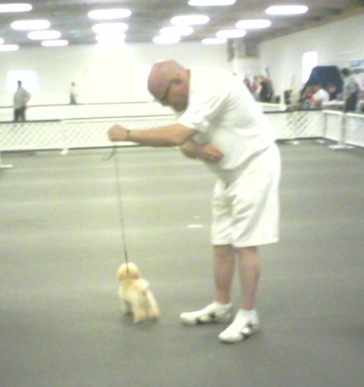

Fuller at our Match in June

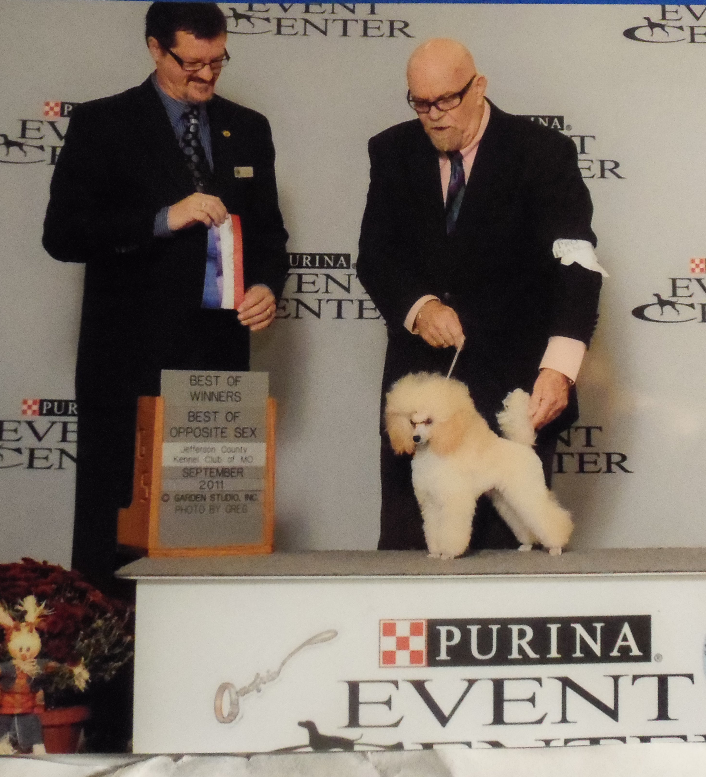

Fuller BOW/BOS Sept. 2011

CONGRATULATION ON ALL
THESE WONDERFUL WINS!

HAVE A
HAPPY VALENTINES DAY!

