

**CIKC INC. NEWSLETTER**

## June 2016

## Champaign Illinois Kennel Club, Inc.

## Officers

**President…………………….…..… Merle Taylor**

**Vice-Pres……………...…… Colleen Woodcock**

**Treasurer…………………………Carolyn Taylor**

**Recording Sec………………...…Sylvia Lofrano**

**Corres. Sec………………….………...Pat Brown**

## Board of Directors

**Robin Haggard Kris Mullen**

**Elise Singer Van Dukeman**

## Breeder Referral…………...……….….Theresa Swift

## Web Page……………..<http://champaignillinoiskc.com>

## Newsletter……….……..…...……..Colleen Woodcock

**Face Book**…...Champaign Illinois Kennel Club - CIKC

**Legislative Liaison**…………..………..Cynthia Nichols

#### Newsletter

Please send all information for the newsletter to Colleen Woodcock at [ashlandkennel55@gmail.com](mailto:ashlandkennel55@gmail.com) by the end of each month.

##### Membership

Prospective new members must attend two meetings (program meeting count as a regular meeting) before a membership application can be turned in. After it is submitted the application will be read by the board two times before voting on membership. Contact Sylvia Lofrano at: [[sylvial@wirelessdatanet.net](mailto:sylvial@wirelessdatanet.net)](mailto:sylvial@prairieinet.net) for more information.

Legislative Liaison

Cynthia Nichols, Legislative liaison CIKC, Secretary, IFDCO [cdnichols@consolidated.net](mailto:cdnichols@consolidated.net)

Club Calendar 2015-2016

October: Working Meeting

November: Program Meeting

December: No Regular meeting (member’s Christmas gathering)

January: No Meeting

February: No Reg. Meeting*,* Westminster Party Feb 15/16

March: Regular Business Meeting (Show) Health Day on March 12th

April: Regular Business Meeting (Show)

April 28, 29, 30, and May 1, 2016 Progress City Cluster Shows with CIKC on the 28th & 30th.

May: Regular Meeting (Show reports)

**June: Program Meeting**

July: Social Event (member’s picnic at Monticello)

August: Regular Business Meeting

September: Annual Meeting (Election of Officers, ***no guests***)

September 24, 25: Barn Hunt

**CIKC June Program Meeting**

The CIKC June Program meeting is a combined meeting of the CIKC and DTCCU. It will be given by AKC Judges; Merle Taylor and Carolyn Taylor. They will enlighten us on why and how dogs are measured and weighed in the AKC conformation show ring.

The program will include a general discussion of breed standards, what a judge has to go through to be approved to judge a breed, how a judge may evaluate a dog when it enters the show ring, and why ringside judging can be misleading.

The program will be held at the DTCCU training building on Tues, June 14th, and will begin shortly after 7:00pm.

All are welcome to attend and learn more about how regulation measurements are done and how the judging process unfolds.

**Progress City Cluster**

Cluster Judges have been hired for 2017.  Once contracts are returned, we’ll have a list at our

next regular meeting.  If anyone knows of approved judges who want to judge an Owner

Handled group, please let Pat Brown, Carolyn or Merle Taylor know.

Progress City Cluster 2016 Close out meeting.  All comments were good.   No future meeting

was scheduled.  Cluster will meet sometime before the Premium List Deadline, which has been

set as December 1, 2016.

Conformation Classes

*Held in the DTCCU Climate Controlled Training Building*

The Summer Conformation classes for the

Champaign Illinois Kennel Club will

begin on **Wed. June 29th, 2016**

at the Dog Training Club of Champaign-Urbana, 2210 West Ford Harris Road, Urbana, IL 61802 located ¼ mile East of the Ford Harris Road and Route 45 (approx. 3 miles N. of I 74)

There will be 6 weeks of lessons; the dates are to be as follows:

June 29th, July 6th, 13th, 20th, 27th, and Aug 3rd.

(we meet in ring 1 on the North end near the kitchen)

Classes are as follows:

**\*\*\*Please Note\*\*\***

**Drop-ins will only be allowed in the 7:15pm class unless prier**

**arrangements have been made with the class coordinator for this session.**

**6:00pm- 4-H Showmanship** (will be working in ring 1 for the remainder of June and will run until 6:45)

6:45**pm- Beginning/Novice Conformation** – For New handlers, puppies and/or dogs just starting conformation showing. This class may move at a slower pace and will cover stacking, gaiting, and general presentation of the show dog. (**Closed to "new" students after July 6th unless approved by class coordinator) Full pmt. for class required.**

**7:15pm- Advanced Conformation –** Open to all handlers with prior experience. This class will focus on ring procedures and practice perfecting ring skills

**Please Note**- Use your discretion if weather is a question.

We will try to announce closings on the email list, on CIKC Facebook, and CIKC’s website, DTCCU will also post on Facebook and on Twitter (If the Dog Training Club Classes are canceled…we are not holding classes either)

Drop-in fee - $10.00 per class per person

***(Make checks out to CIKC)***

##### There will be an info card to fill out the first night and a list of rules for use

*of this facility will be handed out to each new participant.*

Please bring an **updated copy** of your dog's **vaccination record** including proof of rabies

with you on the **first night** of class **to be kept in our files**.

Dress comfortably with good “running” shoes. You may want to bring water for your dog also.

For enrollment & information Contact**:**

**Colleen Woodcock** [**ashlandkennel55@gmail.com**](mailto:ashlandkennel55@gmail.com)

**Please Remember:**

**\*All participants and their guests are expected to follow the guidelines set forth by both clubs at all times while on the grounds. Please pick up your copy of the rules at the ringside table when filling out your class card.**

**\*It is required that all participants pick up after their dogs. Use only the areas marked for**

**this purpose. Equipment is available on the grounds along with a proper outside disposal area. If clean up is needed inside the building, please dispose of all solid waste outside in the disposal area.**

**\*Remember that humane treatment of your dogs is imperative at all times, but especially while on club grounds.**

**\*Bitches in season are not allowed to participate. Please contact the class coordinator if you are unable to attend due to your female coming in season. Beginning handlers are encouraged to come and watch.**

**\*Also remember that Handicapped Parking areas are only for those with the correct parking passes properly displayed.**

**July Meeting is a Member’s Picnic!**

Time for a little Fun!!!

Members, be sure to mark your calendars for the annual Member’s Picnic!

It will be held at the Monticello Forest Preserve Park, Tuesday, July 12th.

More info to come in the July newsletter.

Let Carolyn know if you will be attending so we can be sure to have enough for all!

**Barn Hunt**

CIKC and the Prairieland Standard Schnauzer Club of Central Illinois will be holding another Barn Hunt Trial Saturday September 24th & Sunday September 25th, 2016 at the Bloomington show site.  Mark these dates as we will need all the helpers we can get again.  Don’t forget that you can enter your dog as well.

Find pictures from our last trial at: [**www.barbcunninghamphoto.photoreflect.com**](http://www.barbcunninghamphoto.photoreflect.com/)

Lori & Elise

**>< BRAGS ><**

***BRAGS FROM OUR CLASSES……***

Sonova Winter Born Haven (Saluki) was WB Saturday and Sunday at the Bloomington, IL KC

for 2 more points under Mr. Gladstone and Robert. Frost She is bred and owned by Cheryl

Rosenberger and shown by Sue Ellen Lynch.

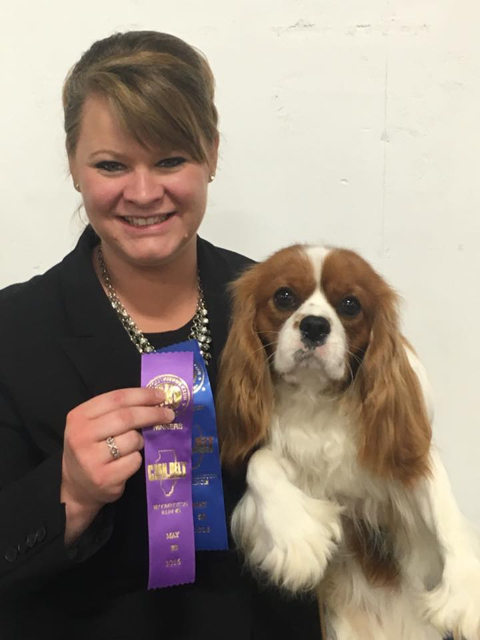

New Champion!!! At just under 18 mo., Cavalier King Charles Spaniel, CH

Snowood Lynwood Royal Hank CD BN RA CGC. “Hank” has had a very

busy, but happy career. He finished his Championship at the Corn Belt

Kennel Club show Sat, May 28th under judge, Richard V Miller. He is now a

very balanced dog with multiple titles at both ends!!

Hank’s performance titles were earned with his owner, Mary Mazzella. He

finished his championship with 3 majors handled by Tracy Richardson. He

is owned by Mary Mazzella.

Bernkastel Just Dance, “Disco”, went to 2 days of Bloomington & picked up a 4 pt major & 2

PTS on her 1 yr. birthday!! ~Julie Miller, KeeRocka Show Dogs.

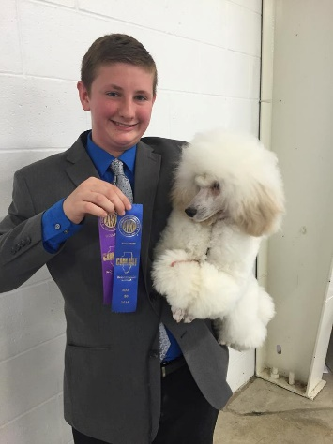

New Champion!!! Miniature Poodle, CH Encor Deagra Wejustfreestylin,

finished his Championship from the 9-12 puppy class at the Corn Belt

Kennel Club on May 30th under judge, Robert R Frost. “Adam” is owned

by Zack Thomas &amp; Denise Agre-Gill and is handled by owner, Zack

Thomas.

***CONGRATULATIONS TO YOU ALL!***